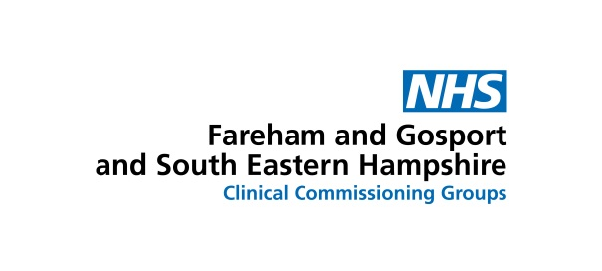

Making evening and weekend appointments – giving you more choice

GP practices in this area are making it easier for you to make appointments at times which suit you.

From October, 2017 all practices in south east Hampshire, and Fareham and Gosport – including ours – will take part in a new scheme to allow you to make appointments from 8am to 8pm on week days, from 8am to 4.30pm on Saturdays, and on Sunday mornings.

This extends the normal opening hours for surgeries, which until now have usually run until 6.30pm on weekday evenings.

If you do need to see someone, we will be able to offer you an appointment at your local ‘hub’ location – they are located at Petersfield Community Hospital, Waterlooville Health Centre, Havant Health Centre, Fareham Community Hospital and Gosport War Memorial Hospital. Patients can also ask to book an appointment at Badgerswood Surgery, in Headley near Bordon, on Saturdays.

There, you will be seen by a locally-based healthcare professional – the service is led by GPs but also includes other staff such as nurses, or healthcare assistants. The staff can – with your consent – access your medical records, ensuring a high quality service.

Please note: the new extended opening hours is not a walk-in service – you need to make an appointment.

You can make an appointment by talking to our surgery staff and booking a slot in the normal way, or – if we are closed and you think you need to see someone more urgently – you can call NHS 111 to ask to make an appointment.

For more information, talk to our staff, or see our Question and Answer document.

